Calculus Based Physics: Lab
PHYS 2110 WA
Date: June 8th 2023
Isaac Abella

Experiment 2
Ohm’s Law

Group:
Isaac Abella

Objective:
The objective was to verify Ohm’s Law through PHET Lab.

Equipment:
A computer with internet access, paper, pencil, calculator (ti84 plus ce/ti 30sx II) , PHET applet

Theory:
Ohm’s law states that the ratio of the voltage across a resistor to the current through that resistor is a constant called the “electric resistance, R” of that resistor.

Denoted as:

V is in volts and I in amps. That makes unit of R to be “volts per amp.” that is called “Ohms”. The symbol for “Ohm” is “Ω”, pronounced: “omega”.

Procedure:
Open PHET Laboratory for circuit construction: https://phet.colorado.edu/sims/html/circuit-construction-kit-dc-virtual-lab/latest/circuit-construction-kit-dc-virtual-lab_en.html

After opening the software, on the left hand side there was options for several circuits, resistors, switches, and bulbs. For this lab, a simple circuit big enough to where the length of the connecting wires in between its elements of a branch is no less than ½ of an inch was constructed..

After creating the circuit, another one was drawn on paper just to keep up with writing down trial results and to also assign values and names to points easier. This was done to differentiate the resistors and to label the flow of the current. Labels such as “I, R, V, A and Vbat” are to be assumed for figures in the same location, order and location. For the circuit built, the left hand resistor was assigned R and the right most resistor was assigned Rheostat. R would be a set value resistor and Rheostat would be manipulated for the following trials.

To conduct the trials, the Rheostat resistor values were manipulated following the trial values on the table in the Data section. Then after changing the Rheostat, the voltmeter attached to the R resistor would display new voltage readings. Likewise, the ammeter also displayed updated readings to the amps flowing in the circuit. These values were then used in Ohm’s law to find the electrical resistance value.

For reference, here is my setup of the lab:

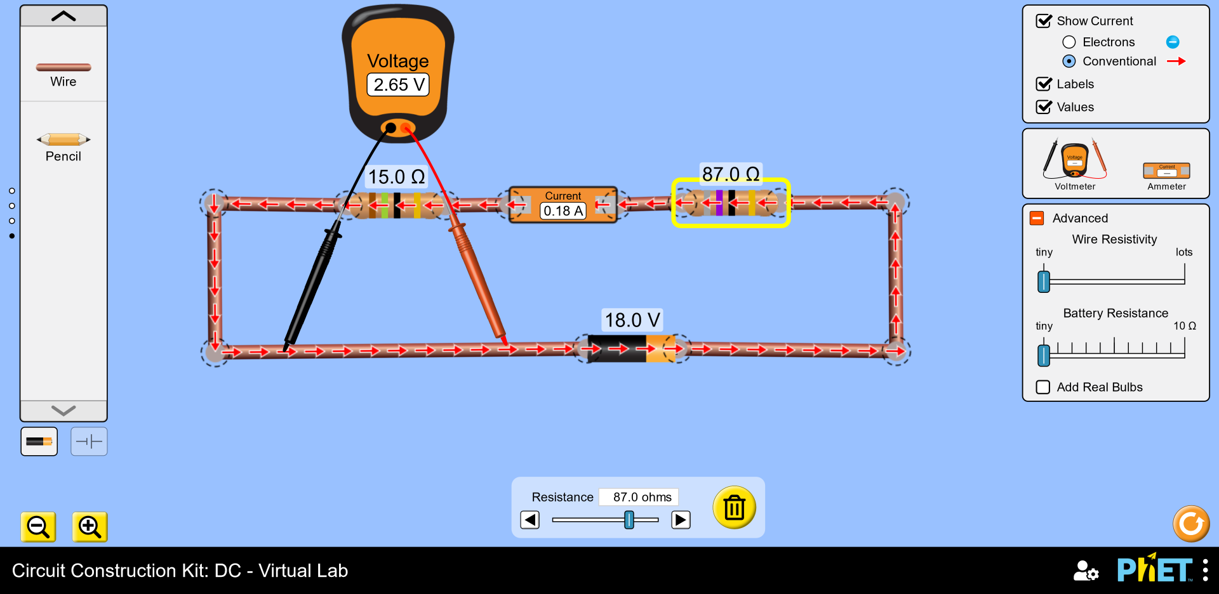
Data:
Given and Measured:

The accepted value for Rs is …..

Trial | Rheostat  Resistance  (Ω) | Voltage V across  Rs  (Volts) | Current I through  Rs  (Amps) | Rs = V/I  (Ω)
1 | 10.0 | 10.8 | 0.72 | 15.0
2 | 13.0 | 9.64 | 0.64 | 15.063
3 | 17.0 | 8.44 | 0.56 | 15.071
4 | 18.0 | 8.18 | 0.55 | 14.873
5 | 34.0 | 5.51 | 0.37 | 14.892
6 | 87.0 | 2.65 | 0.18 | 14.722
 |  |  | Mean Rs: | 14.937

Calculations:
Calculation for Trial 6:

Setting the Rheostat Resistance to 87.0 Volts, the voltmeter measured the resistor R to make 2.65 Volts, and the current flowing the ammeter to be 0.18 Amps. Then applying the Ohms Formula:

The Rs value evaluates to R = 2.65/0.18 = 14.7222… ~ 14.722.

Comparison of The Results
For each case, calculate a percent error only on the mean value of Rs.

Applying the Percent Error Formula:

We get: (15 – 14.937) / (15) X 100 =. 42% Errors

Conclusion
The objective was to verify Ohm’s Law through measuring the voltage of a simple circuit through manipulating one of the resistors while having a controlled resistor. The data collected from trials 1 – 6 give a percent error within the acceptable range of 0% – 5%.

Observing the trails closely shows that as the resistance increases on the Rheostat resistor, the voltage and amps will decrease, leading to a lower electrical resistance R.

Discussion:
The percent error when measuring the mean of Electrical Resistance evaluated to .42%, less than a 1% error in the experiment. This is due to the PHET laboratory have exact sliders to where it is possible to set the resistance values accurately. The only reason that the percent error would be higher than expected would have to do with the trial 6 calculation, which was decided by the student to make the resistance value.

